WKE FactoryView 2014 User Manual



Version: V1.0.9

Author: Abama Cai

Company: Wayne Kerr Electronics

Email abama.cai@waynekerr.net

Table of contents
WKE FactoryView 2014 User Manual 1
I Running environment 1
II File list and installation 1
1 File list 1
2 Installation steps 1
III Login window 5
1 Choose a language 5
2 Measurement Mode 6
3 Connection 6
IV Meter mode introduction 9
1 Toolbar 10
2 Test status sheets 11
3 Other information 11
4、Step Editor 12
V Analysis Mode 13
1 Toolbar 14
1.1 Test button 14
1.2 Measurement setup 14
1.3 Graphic display settings 17
1.4 Instrument calibration 22
1.5 Browse test results and save function 22
1.6 Save image 24
1.7 Sample test 24
1.8 Material settings 24
2 Shortcut button 25
3 Test status display 25
4 Test Value Percentage Marker display 26
VI Resonance search function 27
1 Enter the resonance search mode 27
2 Resonance search mode operation guide 28
2.1 Set the search resonance condition 28
2.3 Search speed 28
2.4 Sets the search depth 28
2.5 Searching range 29
2.6 Set limits for resonant frequency 29
3 Search status and result display 30
3.1 Search status 30
3.2 Search results display 31
4 Tool bar 31
VII Multi-channel test mode introduction 33
1 Software installation instructions 33
2 Software operation introduction 33
2.1 Login interface 33
2.2 Toolbar introduction 34
3 Test Panel Introduction 38
3.1 Product Testing Window 38
3.2 Product Time sweep Window 39
4 Software operation flow 40
VIII Help and support information 41

I Running environment
The software can run on 32-bit and 64-bit windows operation systems, Windows XP and above operation systems have been tested. In order to facilitate the operation and display software, the recommended display resolution is not less than 1024*768.

II File list and installation

1 File list
The following picture appear in all the files, please do not arbitrarily delete, delete any one of them may cause the program cannot run or the software function missing.
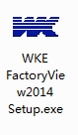

2 Installation steps
2.1 Double-click WKE FactoryView 2014 Setup.exe to open the installation
2.2 Enter the installation interface

*Use administrator rights to install
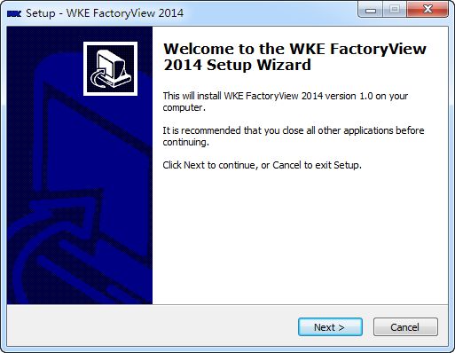

2.3 Click the Next button to go to next step

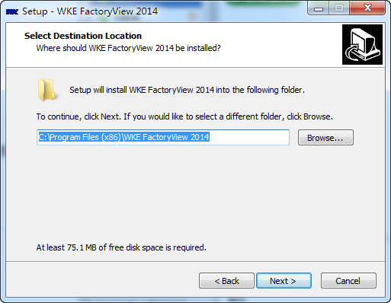

2.4 Select the installation directory, Click Next button to go to next step
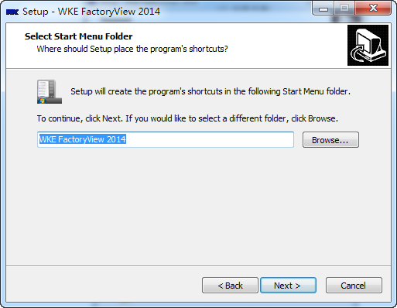

2.5 Modify the program menu to display name, Click Next button to go to next step

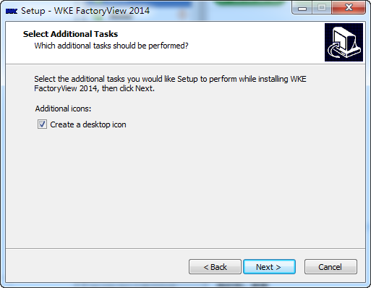

2.6 Select whether to create a desktop icon, Click Next button to go to next step

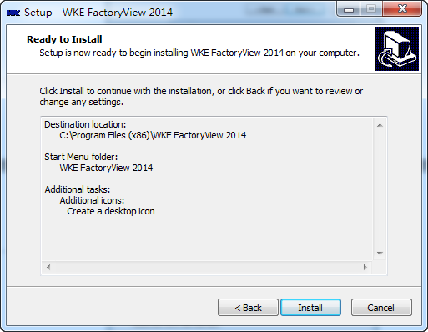
2.7 Display the detail of the installation, Click Install button to go to next step

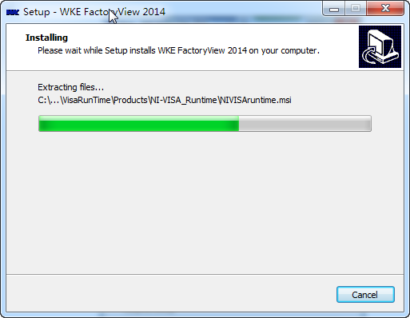

2.8 The installation progress is displayed until installation complete.

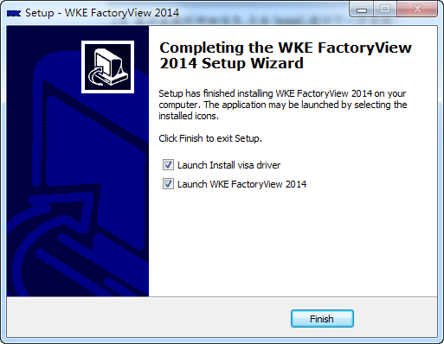

2.9 In the installation completed interface, there are two options:
1） Launch Install visa driver : In the initial installation of this software, be sure to check this one, install the visa driver, or software does not start properly.
2）Launch WKE FactoryView 2014: Start up the software.

At this point, the software installation process finished, if you use USB connection to instrument, please restart computer.

III Login window
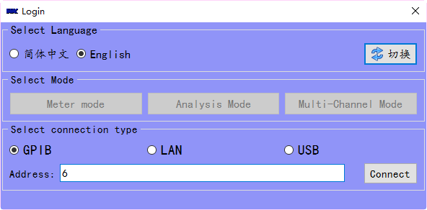

1 Choose a language
The software provides multi-language version, choice the language and click Switch button, the software will load the corresponding language file, so that make use this sotware more convinent.

2 Measurement Mode
Meter mode: for multi-step test, you can edit the steps in this mode for testing.
Analysis Mode: for test a series of changes, for example: frequency, DC bias and so on.
Resonance mode: used to search the resonant point of the measured object, only 6500B(P) has this feature.
Multi-Channel Mode: used to do multiple channels test at one time, or channels cycle sweep tests, this mode must work with WK Scan 10/20.
Note: The test mode can only be selected if the connection is successful

3 Connection
GPIB：select GPIB connection method
LAN：select LAN connection method
USB：select USB connection method

Note: When selecting the LAN connection method, use a set of ordinary network cable to connect computer and WK test instruments. Setup the IP address of instrument and computer is divided into the following steps:
- Set the network address of the instrument, please refer to the corresponding instrument user manual
- The computer set the IP address, open the window like followed picture, and set the IP address.

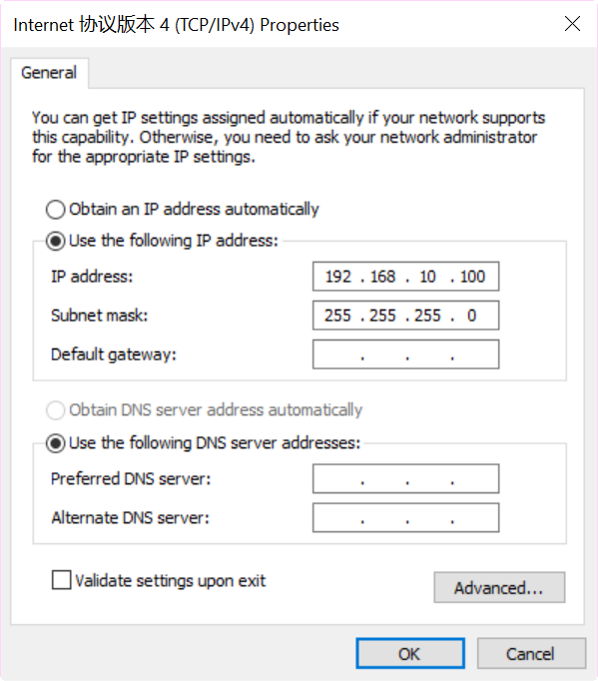
- Though the above configuration, you can use ping command to check whether the instrument can be connected, press keyboard Windows+R keys combination.
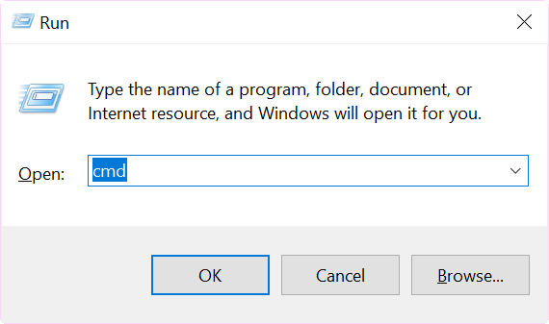
As shown below, the loss is zero, So you can switch to the software to operate.
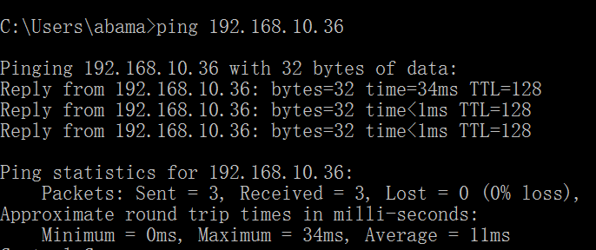

The address text line input the IP address must as the same as instrument. And also, need choice the instrument type you connected.
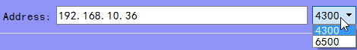

b、When use GPIB connection method to control instrument, the address must as the same as instrument.
c、 When you select USB connection, do not need input in text line.

IV Meter mode introduction
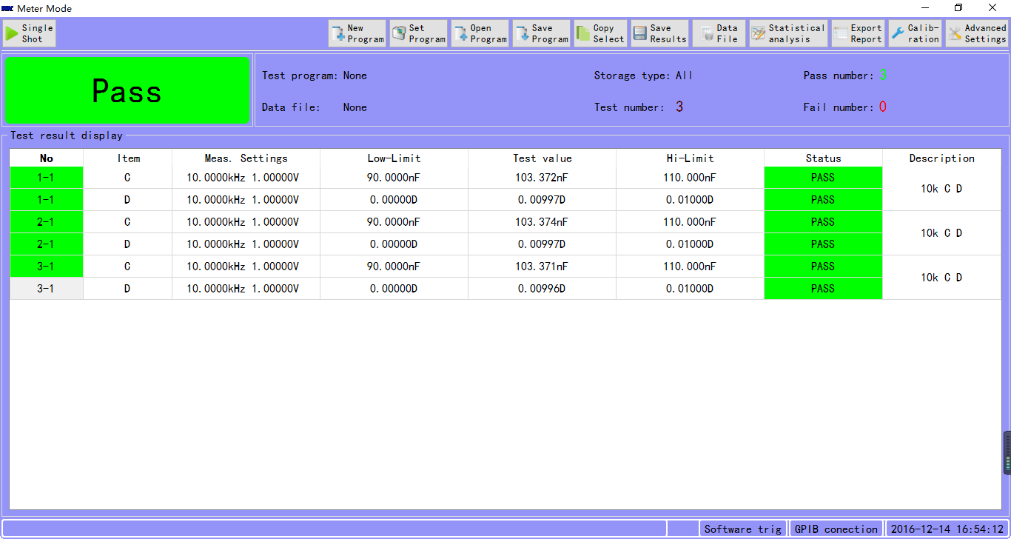

1 Toolbar
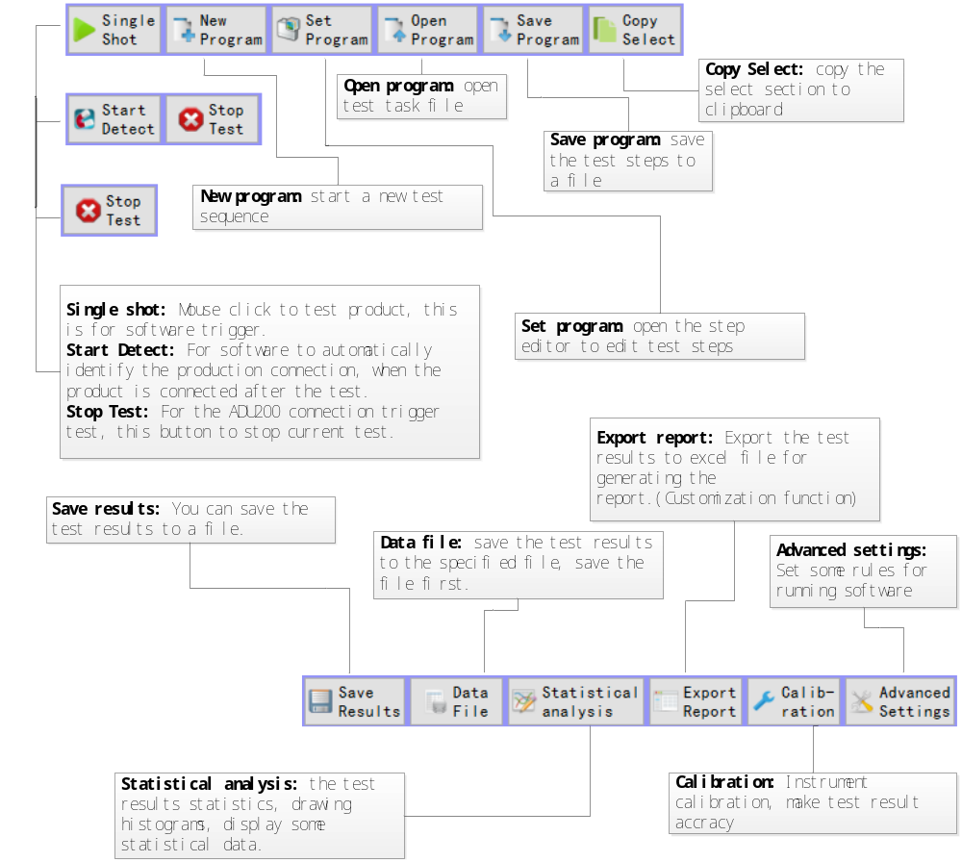

2 Test status sheets
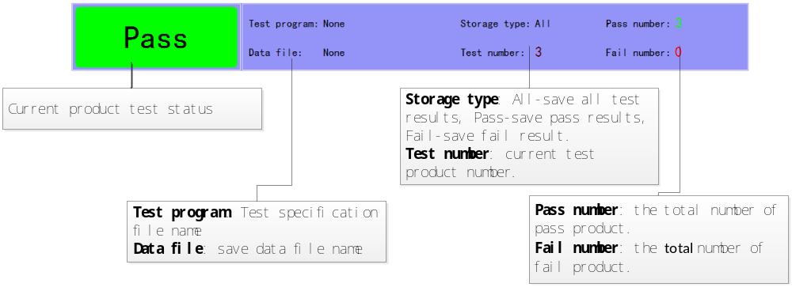

3 Other information
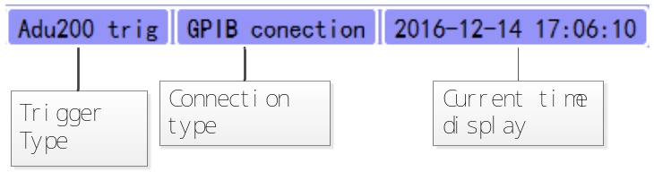

4、Step Editor
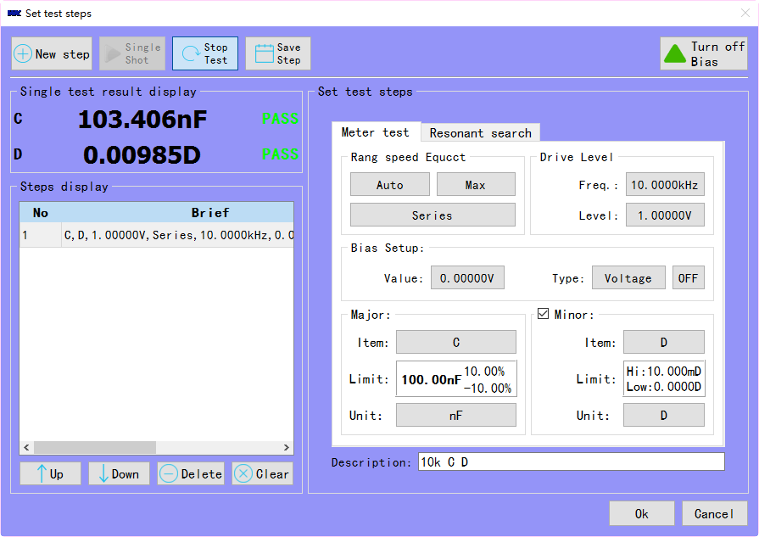
New step: Creates a new test step, the test condition continues with the previous test conditions unless changed.
Single shot: Use current set conditions, send to instrument and trig instrument, get test result back display on the software, equivalent press instrument trig button.
Repeat Test: repeat the test of sample, the equivalent of pressing the instrument repeat test button.
Turn off Bias: when testing, click this button to turn off bias, this is equivalent to press the instrument’s bias button.

V Analysis Mode

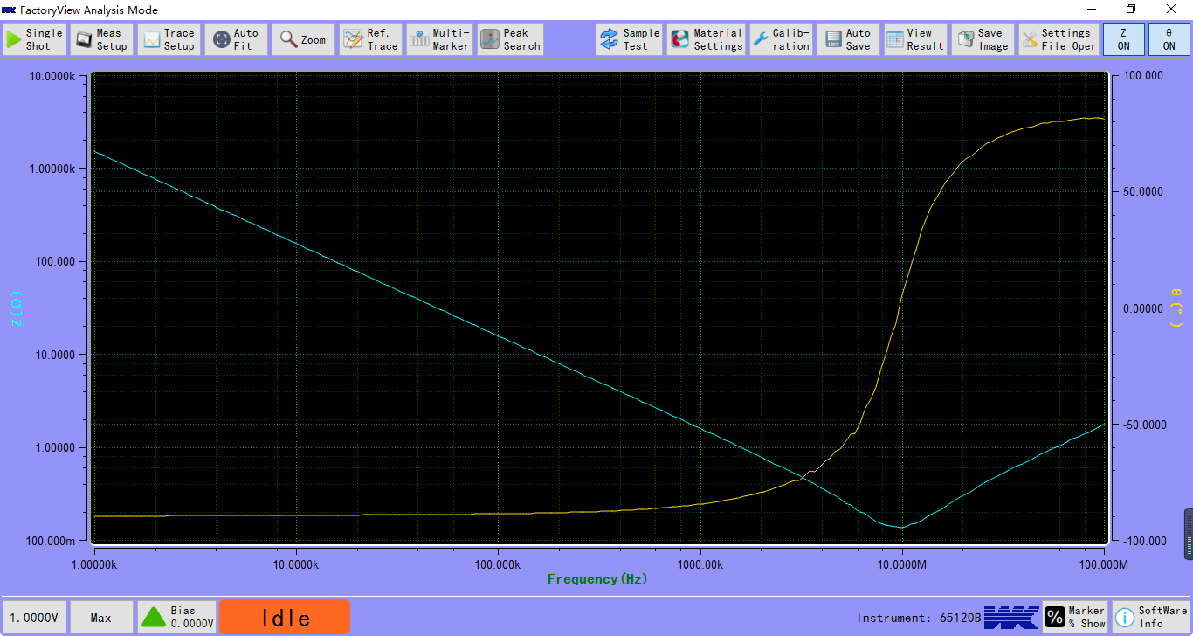
(Software analysis mode screen shots, the test capacitor’s Z vs f curve)

1 Toolbar

1.1 Test button
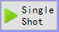：Click to perform a sweep test

1.2 Measurement setup
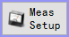：Measurement setup, click the button appears as shown in Figure 2-1 interface, which test speed, equivalent circuit, test level and test frequency settings relate to test result, according to test specifications set the correct test conditions.
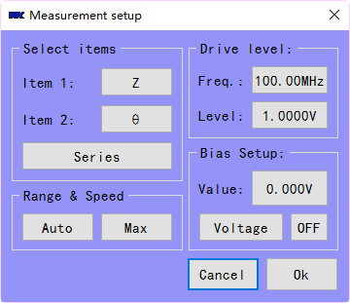
Figure 2-1
Click on the button for item 1 or item 2 will appear as shown in Figure 2-2 interface, only when 6500 has material options, the following parameters will appear, other instruments item options will have different dialog.
.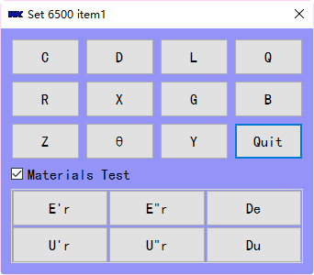
Figure 2-2
Select the item to set new value, click Frequency, Level or Bias button will appear as shown in Figure 2-3 interface, you can enter the frequency you want to set, and the bias value.
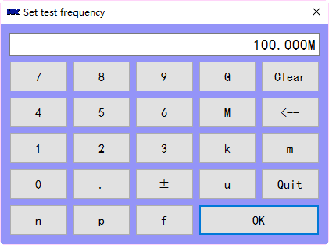
Figure 2-3
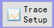：Settings for sweep type and display scales. Click this button will show the Figure 2-4 dialog below to set sweep frequency range, bias range, and time range. you can give the sweep curves a name, and set how many points you want to sweep of this range. The signal level and test speed will be displayed in the lower left corner of status bar. Also, you can also set the display range for item1 and item2.

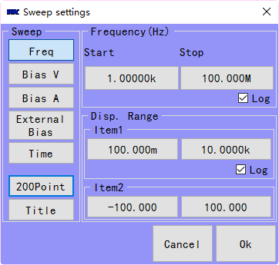
Figure 2-4
Click the parameter setting button or item range display button will appear as shown in Figure 2-5 interface, use this dialog set them.
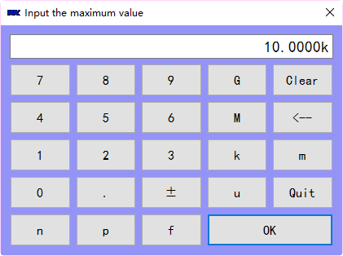
Figure 2-5

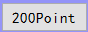Set the test points, the dialog shown as follows:
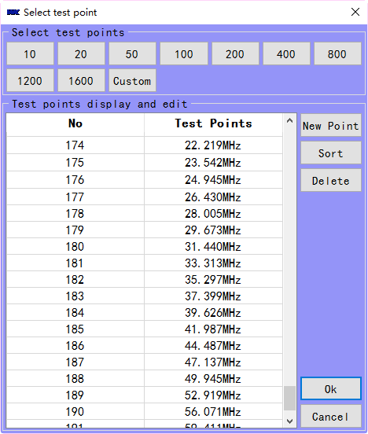
Custom: You can enter the number of test points you want to test
New point: Add a test point the list points do not contain it
Sort: The test points are arranged in ascending order form small to large
Delete: Deletes the selected test point

Note: It is recommended that you press button once before each sweep to ensure that the test points in sync with the range you have set.

1.3 Graphic display settings
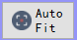: Let test curves get better display. Click the button to make the test curves automatically adapt to size of screen. As shown in Figure 3-1 is not selected automatically adapt to test curves, Figure 3-2 is automatically adapt to test curves.
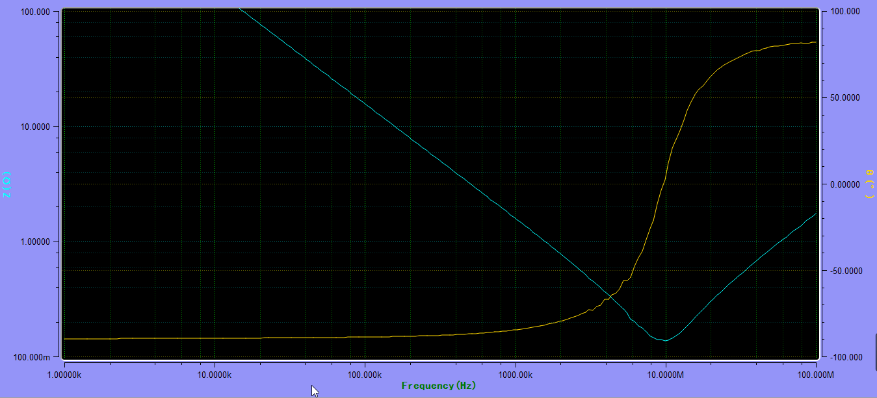
Figure 3-1
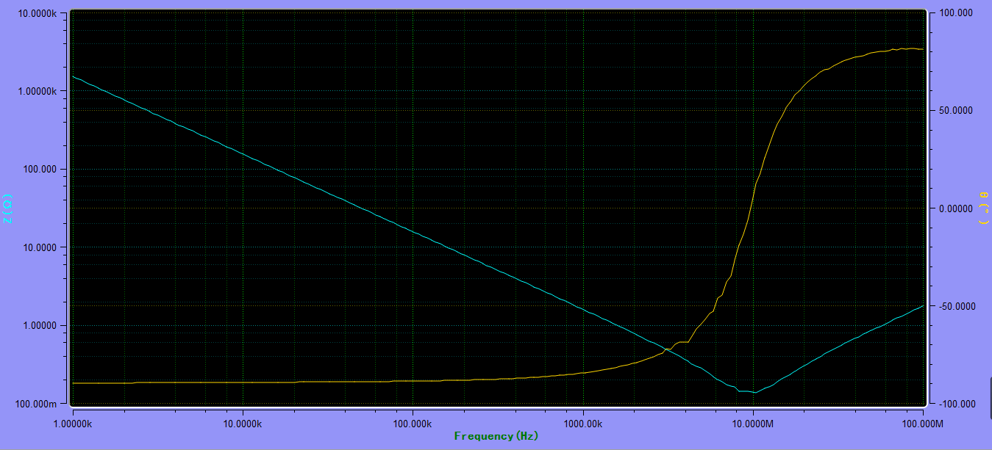
Figure 3-2

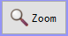： Area sweep for specific range. Select the desired are on the curve, and then re-test, the test interval is to enlarge the curve interval. As shown below Figure 3-3 is not enlarged curve, Figure 3-4 green box for selected zoom area, Figure3-5 for re-test the zoom area.
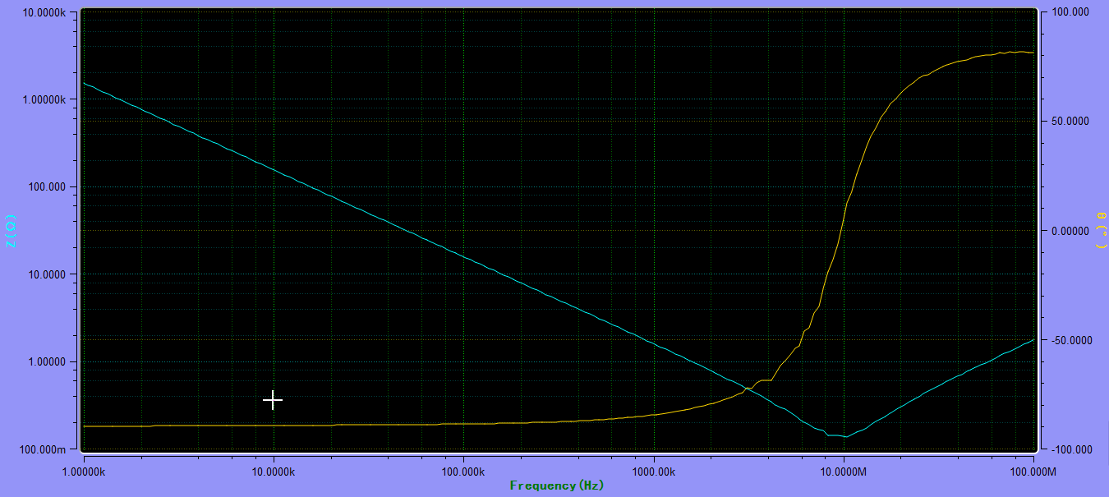
Figure 3-3
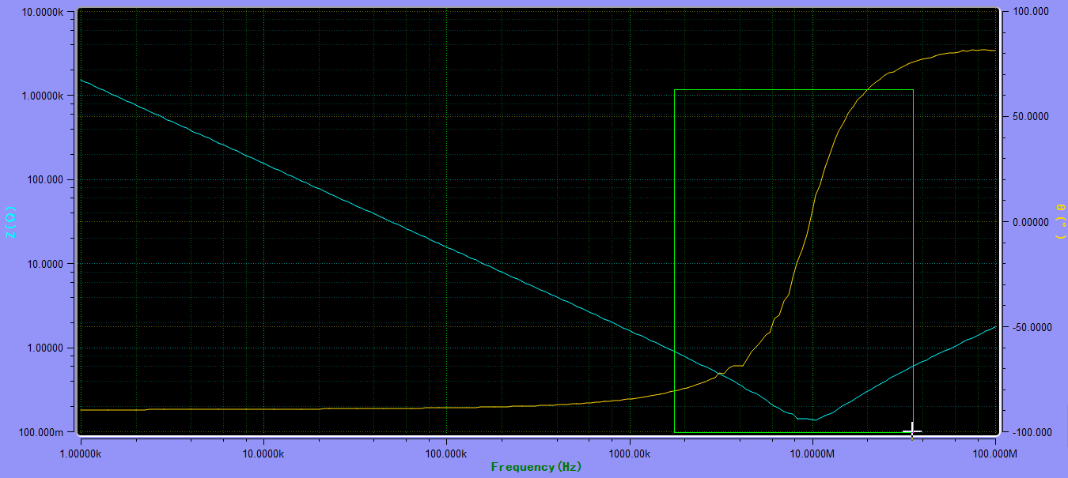
Figure 3-4
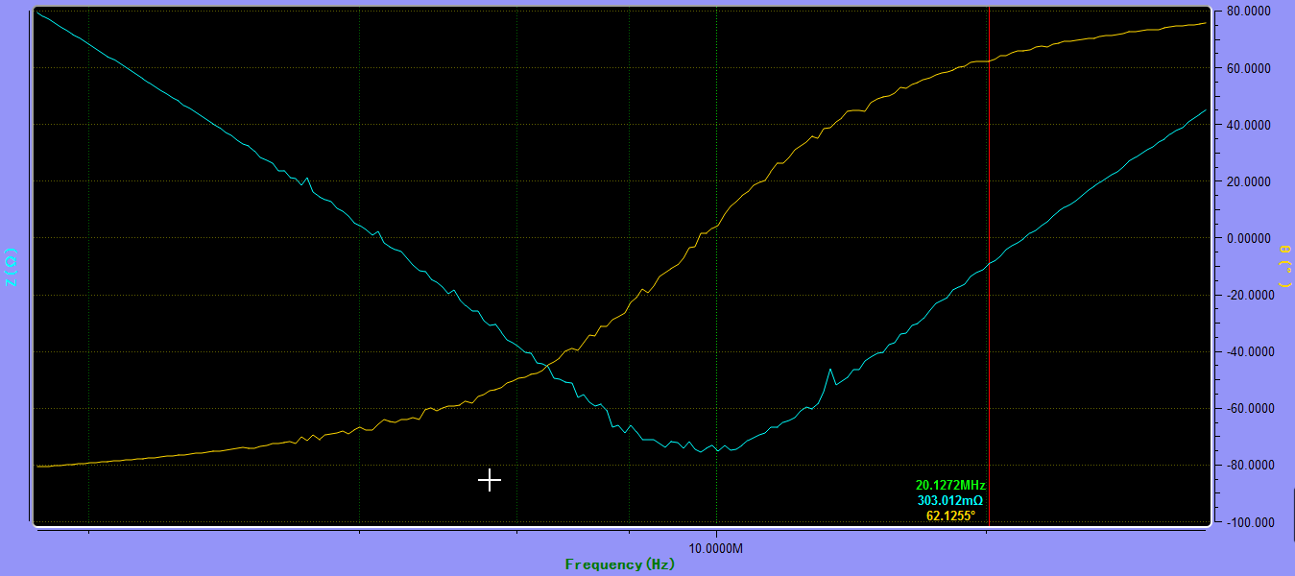
Figure 3-5

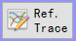： Set multiple curves for comparison. Click the button to appear in the following Figure 3-6 interface to select the current test curve number.
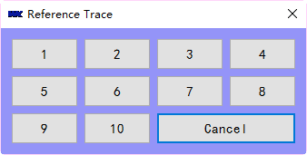
Figure 3-6
After the following Figure 3-7 shows the interface, click switch button to make it in the ON state, use the current test curve can click save curr button to save it to memory. Also, you can use file to load the test data to memory.
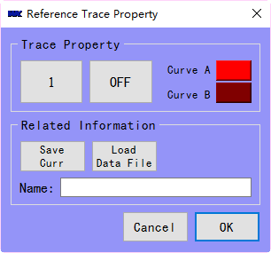
Figure 3-7
颜色并且输入要对比的曲线的名称，点击保存当前按钮并按确定按钮进行保存同时也会把相关曲线的测试数据保存下来，重新点击测试按钮进行对比测试。如果开关处于OFF状态屏幕上就不能显示保存的曲线。下面图3-8即为按照图3-7的设置进行对比得到的曲线（其中红色和紫色为保存的曲线，黄色和蓝色为当前测试的曲线）。
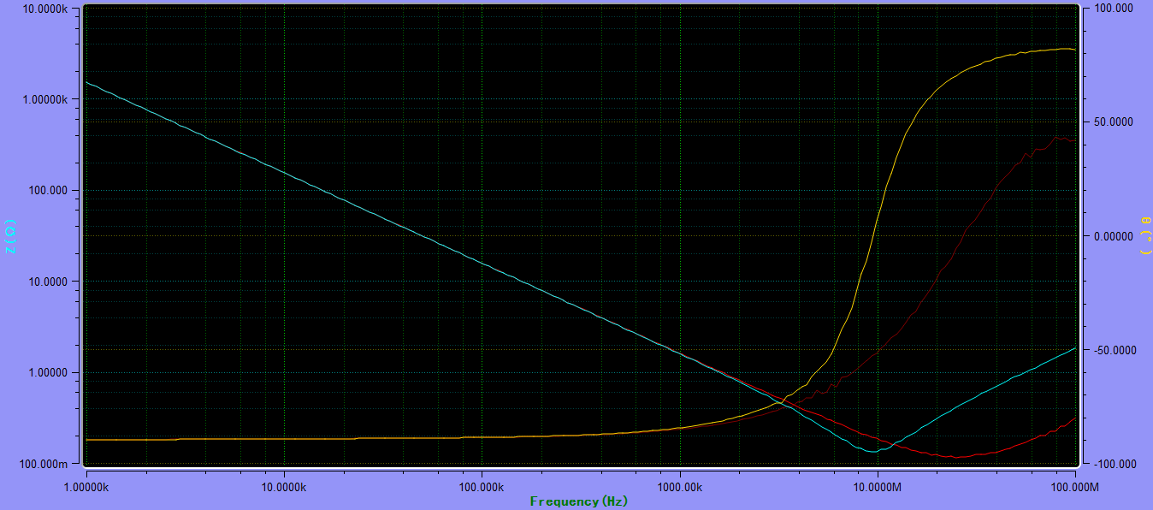
图3-8
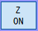：打开或关闭项目一曲线。当项目关闭时时，只显示项目二的曲线，如下图3-9所
测试的项目一为Z，项目二为θ，当Z关闭时图像曲线只显示θ的曲线，

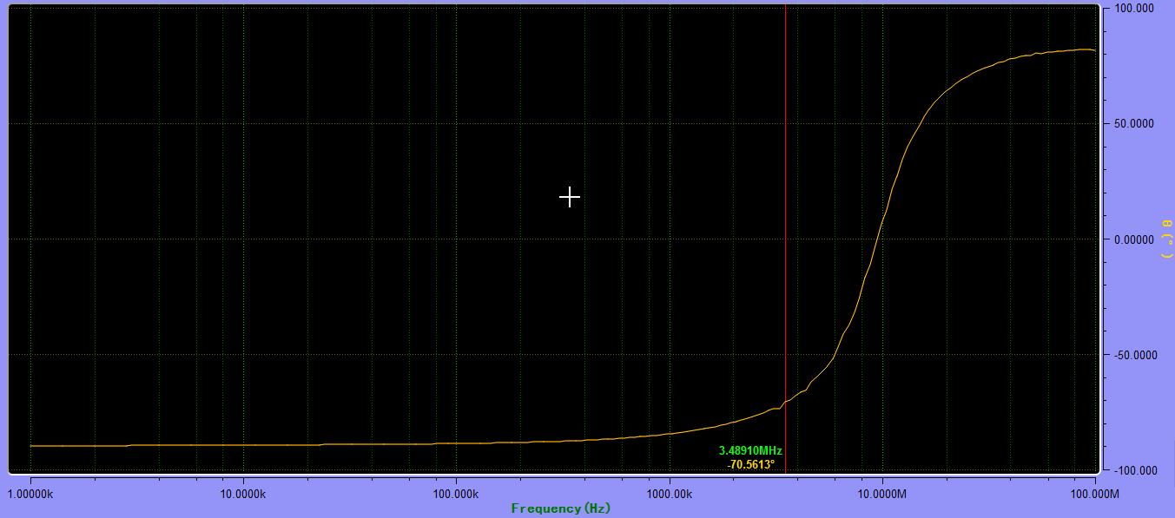
图3-9
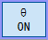：打开或关闭项目二的曲线。当项目二关闭时，只显示项目一的曲线，如下图3-10
示为关闭θ时，图像只显示Z的曲线
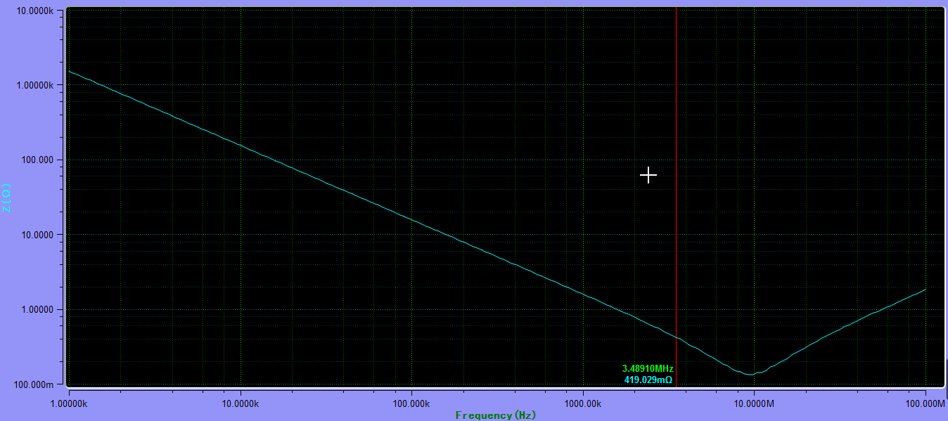
图3-10

1.4 Instrument calibration
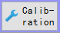：Click this button to bring up the interface shown below to calibrate the instrument. Calibration functions include open-circuit calibration, short-circuit calibration and high-frequency calibration. In the calibration time to see the tips of the information, follow the prompts to operate.
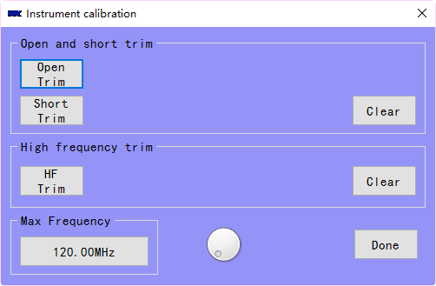

1.5 Browse test results and save function
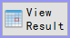：Click the button to view the test results, as shown below and click the Save button to save the test results to disk. Click the Group Number button to view the data for each curve on the interface.

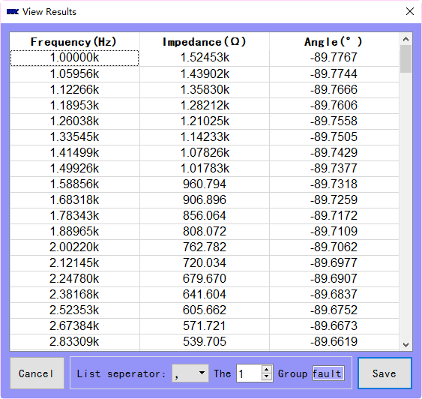

Cancel：Cancel the data view
Group：View the curve which stored in reference trace
Title：Show the default file name when it is saved to disk
Save：Save data to disk in Excel or CSV format
List separator：When the export data is saved in CSV format, the symbol of the data is divided
When the test conditions for the first parameter is the impedance of the second parameter for the phase, sweep parameters for the frequency, save the data can pop up most of the save interface for the user to select in the following dialog.
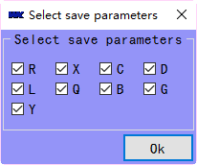

You can check the test parameters, to save more test parameters to the data file.

1.6 Save image
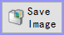：Save the test image, you can save as multiple formats, the default is png format. Click the Save button to save the image to a specific location.

1.7 Sample test
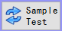 It is recommended to use this function before starting a sweep test to check whether the sample is connected to the fixture or whether it is properly connected. This function is forced on when you do DC bias current sweep. That is, before the sweep, products should be tested to ensure DC bias current can be added to product.
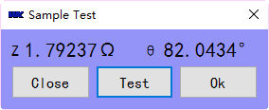

1.8 Material settings
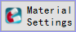 When a 6500 series instrument is connected and the material test option is available on the instrument, this button will automatically appear for the material test setup.

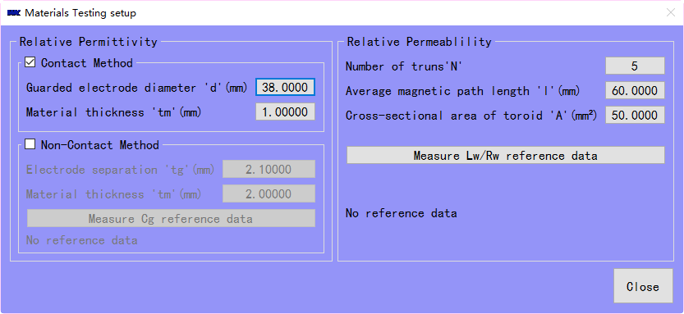

2 Shortcut button
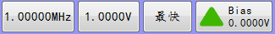：Set the test signal frequency shortcut button, click this button to set the test frequency.
：Select the test speed. Click the button to display select speed dialog. The user can select the speed of the test, the slower the test the more accurate the test data, you can change the software test speed in the sweep.

：Set the test signal level shortcut button, click this button to set the test signal level.
： Bias status and test value display, click this button to turn on or off Bias, when displayed as 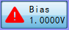, be careful, at this time Bias has been opened, pay attention to security, and close the bias in time.

3 Test status display
When the software in the sweeping process, the software will set the status is busy ，When the sweep is complete, the Status label is displayed as idle .

4 Test Value Percentage Marker display
When the test is complete, click the left mouse button and drag the Marker will appear in the percentage of display. First press 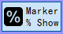the button, drag the Marker can see, there is a percentage display words.
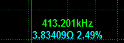

VI Resonance search function

1 Enter the resonance search mode
This function button appears only when the connected instrument is a 6500B (P) series instrument.
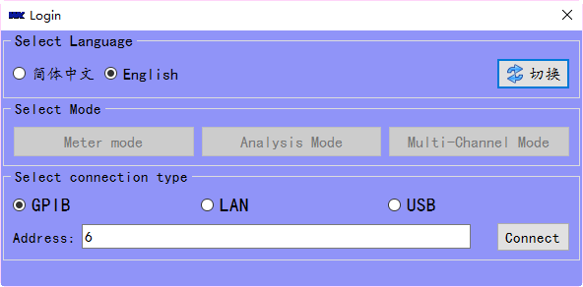
Figure 1 Not click the Connect button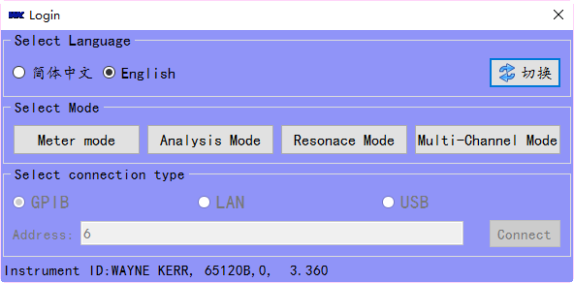
Figure 2 Clicked the Connect button
Click on the Resonance Mode button, show the following interface.
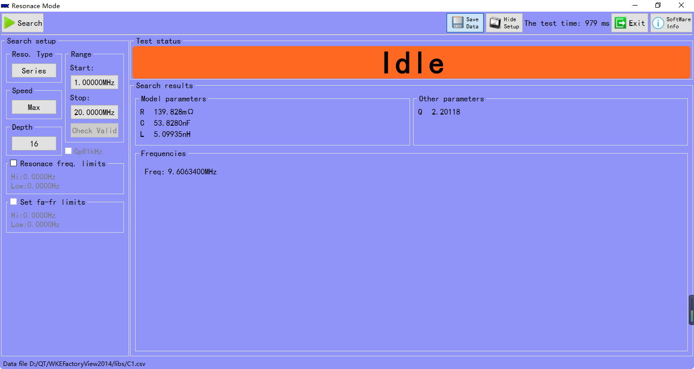
Figure 3 Resonance search mode

2 Resonance search mode operation guide

2.1 Set the search resonance condition
You can set the conditions for resonant search by using the buttons in the search settings box.
2.2 Set the resonant type
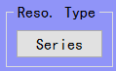 You can use this button to set the type of resonance you want to search. Click the button below to select the type of resonant.
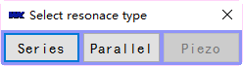 Series: Search for Series Resonance, Parallel: Search for Parallel Resonance, Crystal Resonator: Resonance similar to Resonator type (this function is temporarily unavailable, reserved for future software updates).

2.3 Search speed
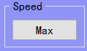 You can use this button to set the speed of searching the resonance point. Click to display the following window. Click the button to select the search speed.
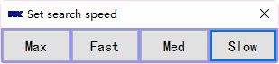 Max: Search speed is Maximum, Fast: Search speed is fast, Medium: Search speed is medium speed, Slow: Search speed is slow.

2.4 Sets the search depth
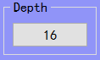 You can set the search depth by clicking this button.

2.5 Searching range
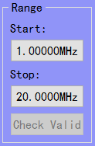 Start button to set the search start frequency, the end button to set the search cut-off frequency. The pre-search button is reserved for future software upgrades.

2.6 Set limits for resonant frequency
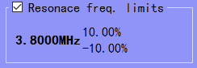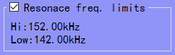
When the check box for the resonant frequency limits are selected, the upper and lower limits of the frequency limits setting are enabled, and the upper and lower limits can be set by clicking on the internal label.
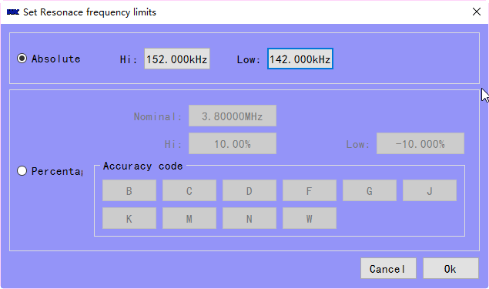
Figure 4 Set the upper and lower limits in two ways
From Figure 4, there are two ways to set the upper and lower limits, one is the absolute value and another is percentage, you can choose, if you already know the accuracy code, you can directly click the accuracy code to set the upper and lower limits.
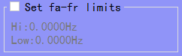 This feature is reserved for software upgrade.

3 Search status and result display

3.1 Search status
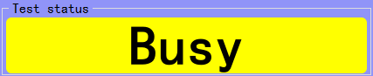
When the search button is clicked, the label becomes busy and tells the user not to click the search button repeatedly. The following three tabs appear.
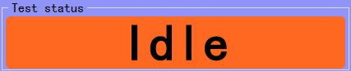
When no upper and lower limits are set, the test is completed and the idle label is displayed.
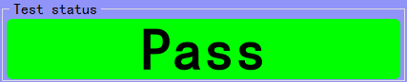
When the test is complete and the resonant point is within the set range, the label is displayed as passed.
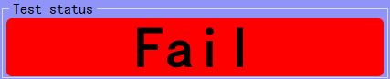
When the test is completed and the search for the resonant point is no longer within the set range, this label appears as failed.

3.2 Search results display
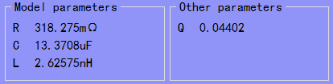
Test results show the RLC parameters, when the choice of series resonance, R = C = L series, selected in parallel is R // C // L in parallel. Q is the quality factor.
Hi Lo Pass, Hi is higher than the upper limit, Lo is lower than the lower limit, Pass is set in the specification.

4 Tool bar
Search: Click to test, until the test is complete, can click to the next test.
Save Data: Click this button to save the test data. If you do not want to save the data, you do not need to click this button. Save the data to CSV format file, display the data as follows:
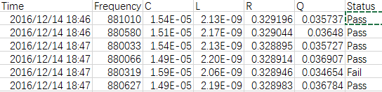
Hide setup: You can hide the setting when you are going to do test.
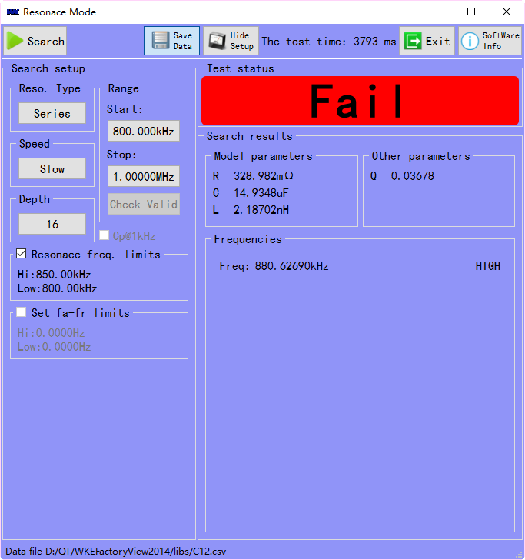 | 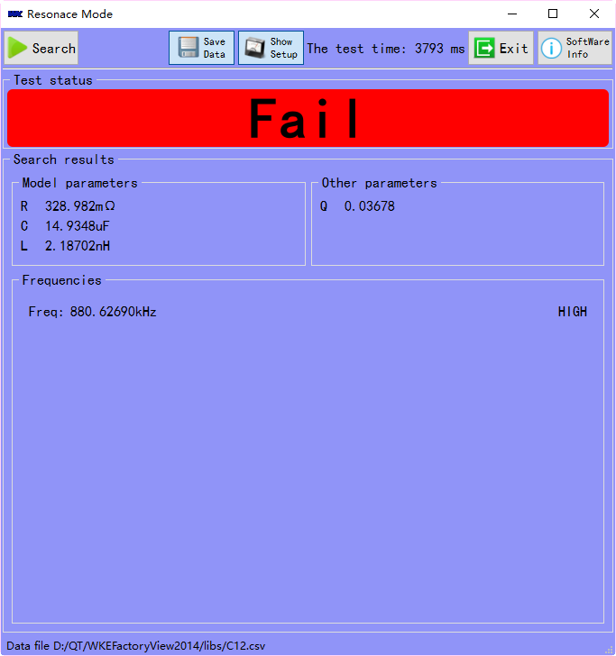
Figure 1 Show setup | Figure 2 Hide setup

Exit: Click this button to exit this mode
Software information: Click to view information about the software, legal liability and software maintenance personnel contact information.

VII Multi-channel test mode introduction

1 Software installation instructions
1 Please refer to the installation instructions of FactoryView to install FactoryView. Please note that to install the software with administrator rights, please install Visa driver for the first time.
2 Scan 10/20 is a USB-232 communication interface. The communication chip is an FTDI chip. Before communication, install the FTDI driver to ensure that the software can find the multi-channel switch box.

2 Software operation introduction

2.1 Login interface
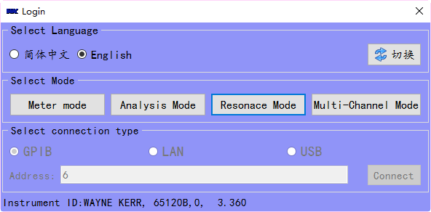
When the 6500 6440 or 6430 is successfully connected, the multi-channel mode button will appear. Click the Multi-Channel Mode button to enter the multi-channel test mode.

2.2 Toolbar introduction
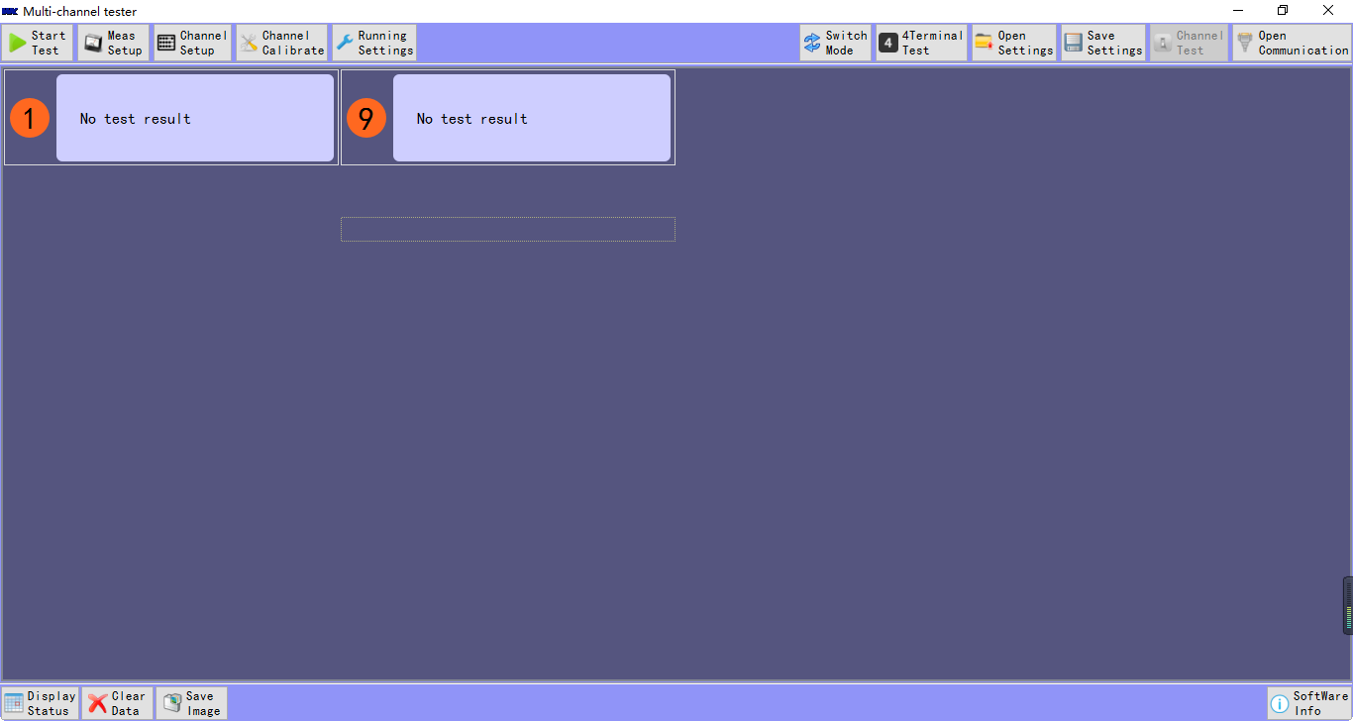
2.2.1 When the open communication button appears, the channel test is not available, indicating that the software is not successfully connected to the multi-channel switch box, you need to check the multi-channel test box is power on or not, USB cable is connected to the computer.
2.2.2 Start test: test currently selected mode.
2.2.3 Measurement setup
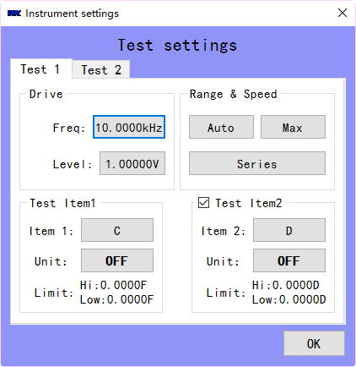

Measurement settings, the main test conditions are set, drive signal, range and speed, are set directly to the instrument, and test items, there are items 1 and optional items 2, are returned to the instrument test data through the calculation, cannot directly look at the data on the instrument, otherwise the two data are different.

Particular note is that the unit button option, when you click the button next to the unit will appear similar to the following dialog box,
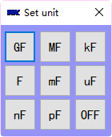
This dialog box is to select a formatted data unit, default the system format select OFF, if you select other symbols to do units, such as the choice of k as a unit, test data 100, the software shows 0.1k.

2.2.4 Select channel
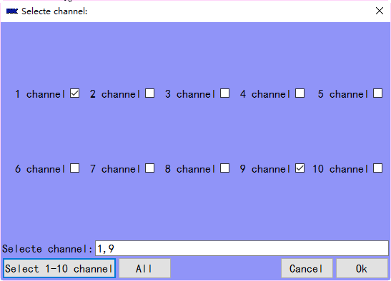
Click on the corresponding channel label to select channel to do test.
2.2.5 Channel calibration
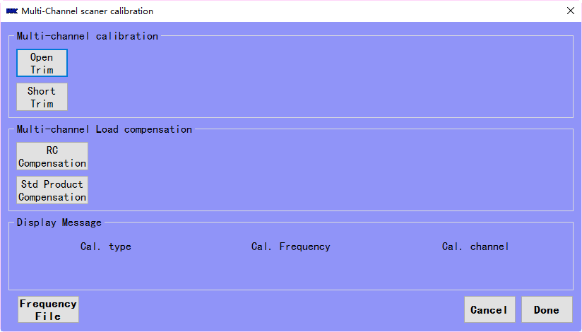
Note: Before calibrating with the software, clear the calibration data of the 6500 or 6440 and perform this calibration.
When performing the calibration, pay attention to reading the software prompts.

If you want to use the frequency for the future, such as the current frequency of only two possible later use more frequency points, you can click on the Frequency file button, select the data has been written frequency points file, so the software reads the frequency points file content, Frequency point file to be calibrated, do not worry, the software will automatically join the two frequencies you set in the meas setup dialog.
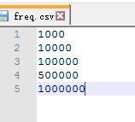
The RC calibration is calibrated using WK calibrators 100R and 100pF.
Standard sample calibration, you can use their own factory standard sample calibration, click on the standard calibration button, will pop up the standard on which a channel for testing, and then you can select the standard combination of parameters input, the corresponding standard data, and then Calibrate each of the following channels.
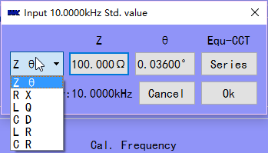
The default is the ZA combination, depending on the product type can choose different combinations.
2.2.6 Running settings
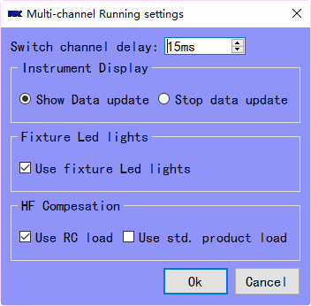
Switch channel delay: In order to increase the stability of the test data to prevent the relay bounce.
Screen display: you can turn off data updates and open data updates, the use of 6440B or 6430, it is recommended to close the data update, so you can get better test data accuracy.
Fixture LED lights: Used to turn off or open the LED indicator on the fixture.
HF compensation: check the different options, the use of different calibration data, the use of resistance-capacitance compensation is usually a large range impedance of the product, the use of standard sample compensation, usually for products with a small range of products, such as a batch of product testing.

2.2.7 Switching modes
You can switch between different modes to test by clicking this button, but switching the mode will terminate the current mode test. Cycle through the product test mode and time sweep mode.

2.2.8 Test port settings
Can set the multi-channel switch box test terminals, display 4- terminal, switch box and 4- terminal test, display 2- terminal switch box is 2- terminal test.

2.2.9 Open and save the settings
Open the settings to apply the saved configuration file to this mode.
Save the settings and save the configuration of the current mode as a file.

2.2.10 Channel test
This test the channel can work properly, a collection of functions (for development use, the latter product will not release this feature).

3 Test Panel Introduction

3.1 Product Testing Window
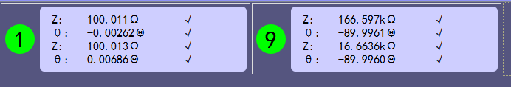
When you set, the channel will appear in the test panel with the channel number, place the product, click on the toolbar to start the test button, you can test, if you want to manually test, you can click the digital label 1 and 9. Click the Result tab to display the test status of the product, and turn on the fixture's LED, etc., and the LED and so on can be changed to corresponding colors.
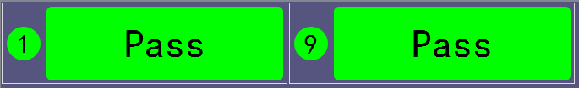
In order to better view the test data or test status, you can display status or display data button to switch the display of test results.
Clear data, you can clear the above test data, and test the state is set to idle, in order to prepare for the next test.
Save image, the test window will save the test data into pictures.
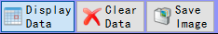

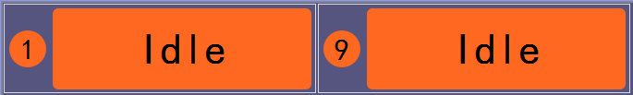

3.2 Product Time sweep Window
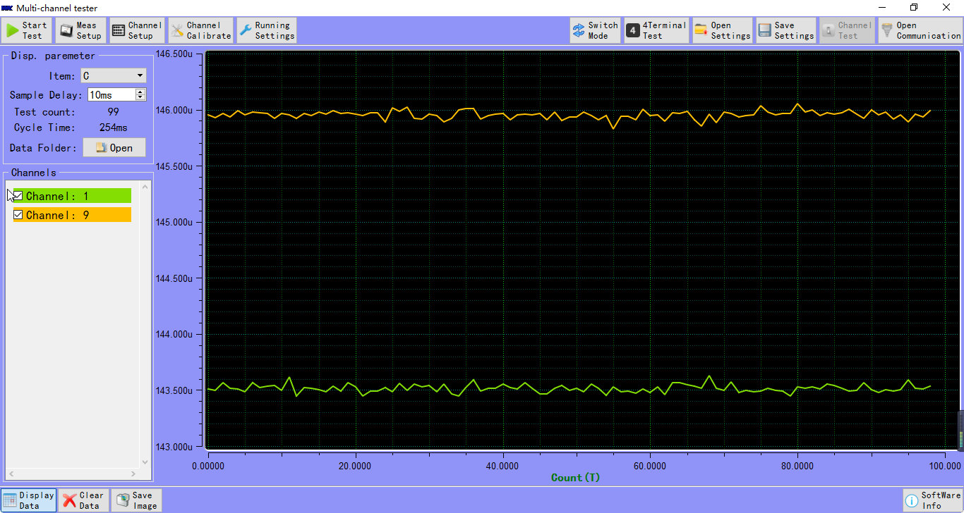

When you click the Start Test button, you can change the parameters of the product over time.
Display parameters can choose different parameters to display, check the different channels, there will be different test curves displayed in the test window, all the test data is automatically saved in the data folder, the file naming rules: day _ month _ Year _ minutes _ seconds _ channel.txt, you can open data folder to test data.

In order to faster scanning speed, in the testing, please don’t check the channel, so that test data is not displayed in the window, make software run quickly.

4 Software operation flow
4.1 Open the software, select the type of connection, enter the address of the instrument, test the connection is successful.
4.2 Enter the multi-channel test mode, see whether the multi-channel switching box is connected successfully, that is, whether the open communication button appears or not, disappear connection button means the connection is unsuccessful.
4.3 The above is no problem, set the multi-channel test box work in the 2-terminal test mode or 4- terminal test mode.
4.4 Open the Meas setup dialog, set the frequency and parameters to be tested and so on.
4.5 Click channel button and select the test channel that has been connected.
4.6 Channels calibration.
4.7 in Running Setting, select the type of high frequency compensation.

Till now, you can test.

VIII Help and support information
【WKE FactoryView 2014】is for WK instrument online testing software, test product types include electronic device, magnetic materials, piezo crystal and other passive device.

Software author: Abama Cai, Email: abama.cai@waynekerr.net，Tel:0755-26523879
Finally, thank you for using this software, I hope you can give use suggestions and comments.

